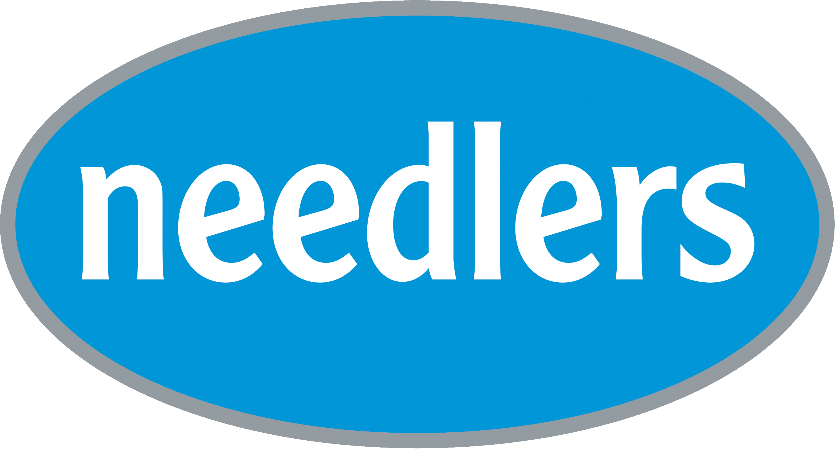
Reference: HD/P1318/19/PS
Version: v2
Product: P1318
Date: 09/09/2019

PRODUCT SPECIFICATION

RELDEEN SURFACE DISINFECTANT WIPES
Product code: P1318
Size: One size
Colour: Blue

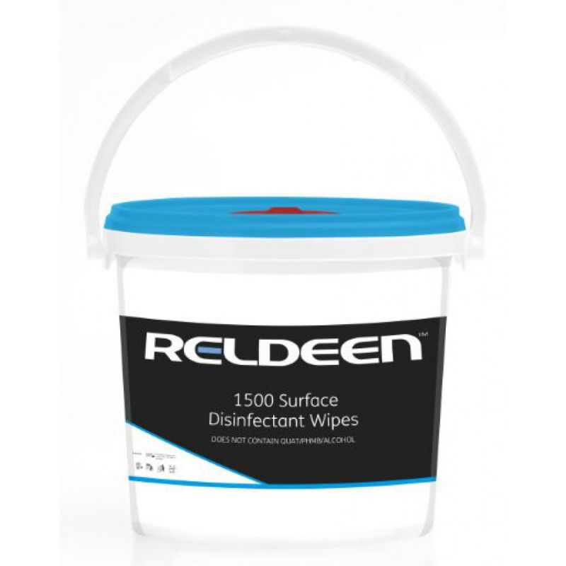

Features
- QUATS, PHMB and alcohol free
- Material: 100% Polypropylene
- Active ingredients: N-(30-Animopropyl)-N-dodecylpropane-1, 3-diamine
- 1500 wipes

Applications
- Designed for cleaning and disinfecting within food manufacturing and service environments

Needlers Limited, Reldeen House, Wyke Way, East Yorkshire, HU14 3BQ | Reg: 5536210 | VAT: GB 870 8678 77
needlers.co.uk | sales@needlers.co.uk | 01482 467500

